**F17 IS 661102: User Experience Design: Final Report**

Date: 4/28/2017

Version: 1.0

Group Name: SPUNK

Group Members:

Ankita Dutta

Akshay Umesh Punde

Keka Nandi

Preeti Boddupally

Samtha Reddy

**Contents**

Section 1: Course Project 3

Section 2: Primary Persona 4

Section 3: Secondary Persona 5

Section 4: Problem Statement 6

Section 5: Primary Persona Problem Scenario 7

Section 6: Primary Persona Problem Storyboard 8

Section 7: Secondary Persona Problem Scenario 9

Section 8: Secondary Persona Problem Storyboard 10

Section 9: Vision Statement 11

Section 10: Primary Persona Activity Scenario 12

Section 11: Primary Persona Activity Storyboard 13

Section 12: Secondary Persona Activity Scenario 14

Section 13: Secondary Persona Activity Storyboard 15

Section 14: Prototype Sitemap 16

Section 15: Prototype Screenshots and Descriptions 17

Screen Name: 17

Screen Name: 18

Screen Name: 19

Screen Name: 20

Screen Name: 21

Screen Name: 22

Screen Name: 23

Screen Name: 24

Screen Name: 25

Screen Name: 26

Screen Name: 27

Screen Name: 28

Screen Name: 29

Screen Name: 30

Screen Name: 31

Screen Name: 32

Screen Name: 33

# Section 1: Course Project

Let’s face it – success in college involves more than just attending classes and studying long hours. The people we learn from and with have a tremendous effect on our education and grades. Often times a course is taught by several different professors. One may inspire us and be instrumental to our education, while another may confuse us and stifle our learning. Which professor should we take such a class with?   
  
As classes become more collaborative, we often find ourselves having to work with and rely on our fellow students for group projects and assignments. Some students prove to be great allies, while others become liabilities and sources of stress. Which students should we work with?   
  
Simply put, our professors and fellow students have a significant effect on our college education and grades. The modern student is keenly aware of this and wants to make the right decisions about whose class to take and which students to work with.   
  
**Problem**: College students are frequently unhappy with their choice of professors and student group members because they are making ill-informed decisions about whose class to take and which students to work with.   
  
**Solution:** Students need more information about professors and fellow classmates to make appropriate decisions about who to learn from and with. This information is called *reputation*.

# Section 2: Primary Persona

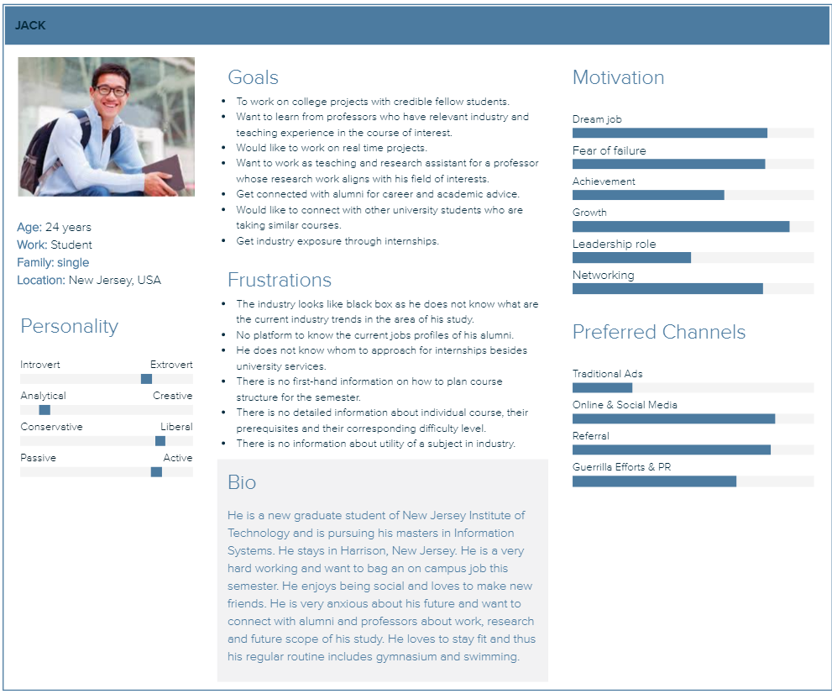

# Section 3: Secondary Persona

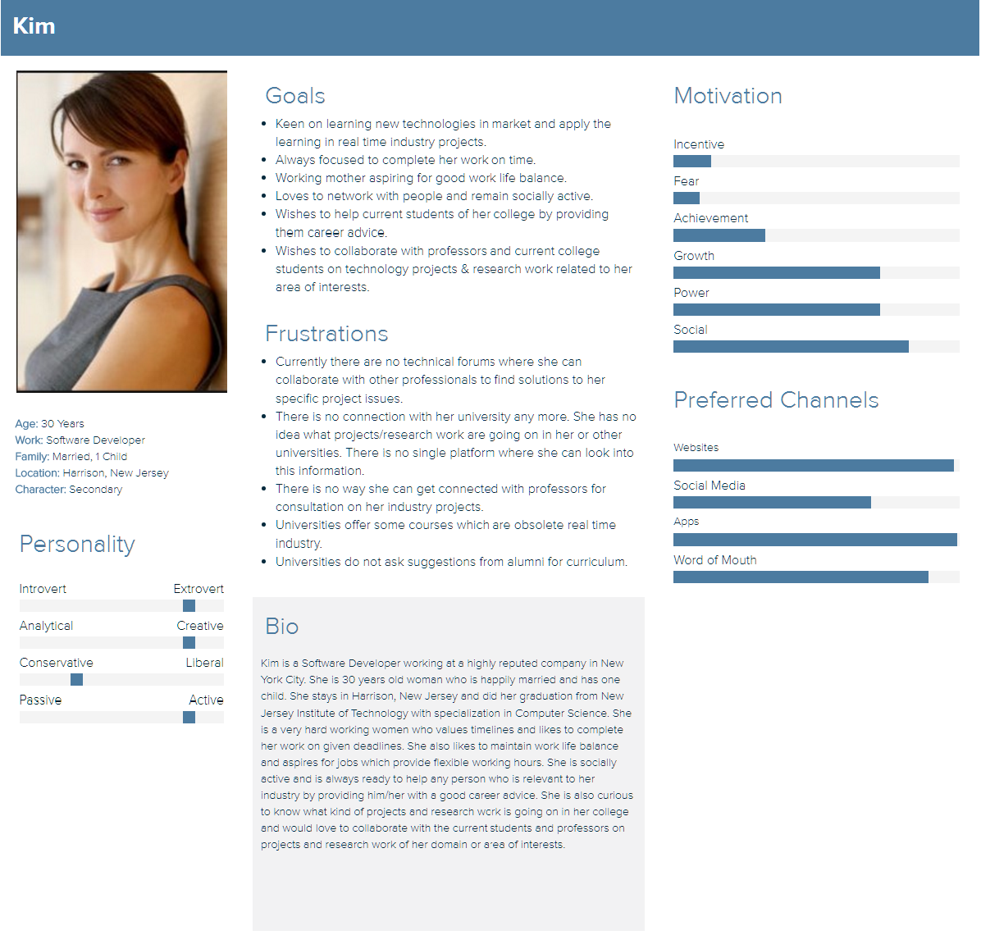

# Section 4: Problem Statement

Students and Alumni feel there is the unavailability of information about ongoing projects/courses/research-work in various universities. In addition, students are not able to discuss the future scope of their field of study with Alumni and get career advice. The students are discontent because they cannot identify good professor to learn with and compatible fellow students to work with.

# Section 5: Primary Persona Problem Scenario

Jack is a new student in XYZ University. He is pursuing a masters’ degree in Information Science. He is a hardworking and bright student.  He intends to gain advanced knowledge from his master’ degree to succeed in his future career.  The semester has started; he is trying to identify which course to choose. He wants to pick courses, which are relevant to current industry trends and will help him achieve specialization in data analytics. For this purpose, he would like to connect with alumni who is already successful in this field, as the alumni can suggest him most relevant course with respect to the current industry trends. However, he does not know anybody from the alumni community. Post discussions with fellow students and academic advisor, he decides which courses to pursue.

Two different professors are teaching a course he is interested to study. He is confused, under which of these two professors he should take this course. He searches each of these professor online to know about their research work, industry experience and reviews provided by his/her ex- students. Based on his research from various sources he makes a decision. As the semester progresses he has to team up with fellow students to complete project work. The professor has given each a student a week to come up with their teams. Being from a non-statistics background, he wants to team up with students who have some prior knowledge in statistics. However, Jack being an ambivert person, and this being his first semester he is not acquainted with all of his classmates, so he randomly chooses his teammates.

By the end of semester, he realizes that one of the subjects he chose was not as comprehensive as suggested in the description of the course. In addition, he was not happy with his choice of professor and some of his project mates, since the professor Jack picked focused more on exams than project work. He was not happy with this style of teaching.

Most of his decisions were based on information available on the internet. Alternatively, discussions with fellow or senior year students did not provide him the guidance he was looking for. During the winter break, he wants to learn a course offered by another university in his neighborhood. Again, he is confounded with many queries. This university’s site is completely different from his university site, he has to again struggle to get more information about the professors and the course curriculum.

There is no single platform where can search about professors/ fellow students/alumni of his or any other neighboring universities in his area.  A platform, which not only provides him legitimate and verified information about these professionals, but also provides a medium to connect with them.

# Section 6: Primary Persona Problem Storyboard

Macintosh HD:Users:Saraff:Downloads:SPUNK_primary persona problem storyboard Keka.pdf

# Section 7: Secondary Persona Problem Scenario

Kim is an alumnus of New Jersey Institute of Technology. It has been three years since her graduation. She is now working as a software engineer in ZED Technologies. She is married and has one child. She is a hardworking woman for whom learning the latest technology in the market is one of the top priorities. In her current project, she is facing some issues. She remembers one of her university professors was doing research work on a similar topic. Maybe that professor can help her in resolving the issue. However, she does not know how to connect with the professor. She is not able to find the professor contact details in any of the popular social media.

In due time her project will complete. She will start her job hunt soon, and hence want to prepare herself.( Comment: Please Remove)

One day while she is browsing through her university’s website, she is shocked to see some of the obsolete course are still being taught in her university. Nevertheless, she does not know whom can she connect within her college and give her feedback about the curriculum. She has no connection with her alma mater anymore.

Kim discovers the university does offer a hybrid/online course in the technology of her area of interest. The course curriculum involves project work.(Comment: Please remove)

She wants to get hands-on experience on the new technology she is learning. Hence, she searches through her university site to look for ongoing projects in that subject. Unable to find any information on the site, she searches on the internet for on-going projects in that technology. After many trials and errors, she is finally able to connect with a group of students who are working on a project in that technology. On discussion, she realizes that most of the scenarios which the students had included in their project, are no more relevant in the Industry.

Having been a student herself, she understands they need appropriate guidance so that their project work is relevant to current technologies and industry trends. This is important as it helps during job interviews. She also feels dejected because the students are not very keen to involve any new person in their project as they are already half way through the project. Searching on internet, finding and connecting with another group of students working on similar projects is stressful.

Being a working mother it is very difficult for her to spend so much time on the internet searching for the right information. She is looking for a single platform where she can get information about previous and ongoing projects and research work conducted by professors and students in her university as well as other universities.

# Section 8: Secondary Persona Problem Storyboard

Macintosh HD:Users:Saraff:Downloads:SPUNK Secondary Persona Problem Storyboard.pdf

# Section 9: Vision Statement

The new platform will help student, professor and alumni to connect with each other on ongoing projects/research-work to be able to consult and work with each other. It will be an informal collaborative platform where students can get relevant information or help needed to succeed in their academics and future career.

# Section 10: Primary Persona Activity Scenario

Jack is excited to start his new phase – (Remove Highlighted Part) as a student in his dream graduate school. He knows that he will quickly register for the upcoming semester courses and he wants to gather as much information (about courses and lecturers) as possible and make well-informed decisions. His friends and seniors tell him about a very helpful and popular app named “Geek Genie” which helps him find best courses to pursue for his specialization, best professors for those courses, best fellow students to work with, medium to connect with alumni for career advice and also information about on-going project and research work. He quickly downloads the app from Google Play Store/I-store and does a free sign-up.

He searches with the university name. However, he could only find some top reviews of the school, most popular professors & their reviews. However, he wants to streamline his search further by using the advanced search option where he can filter by semester, major, degree etc. He clicks on the advanced search option, and browses through many courses of his interest including some of the “suggested courses” from the site and finally shortlists few courses from the “Highly recommended” section and selects some professors from the “Most popular” section based on reviews & ratings.

While he is browsing through the sections, a pop-up window opens up to ask him if he would like to get notified about people who have similar interests of courses(Remove), students who might have completed the course or graduated from same school or for any new updates on his choice of courses. Jack thinks this is a good way to stay updated and clicks on the “Yes, Notify Me” option. This way he can come back to the site again, only when there is a notification that interests him.

Just then, he receives a mail saying that two people classified as Alumni from the same school and major that matches with Jack’s profile are active on the site. Jack clicks on a “follow” button and posts a small note, saying Hello and that he wants to seek guidance on course selection and needs career guidance. After a day or two, he is happy to receive a notification that the alumnus has replied to his queries and suggested some good courses and the highly recommended professors for the same.

When the course registration starts at the university, Jack can successfully enroll for three courses from his well-prepared shortlist of courses. As the semester progresses, Jack is satisfied and intrigued by how “Geek Genie” app helps him make the correct choices for his career. He likes the app and is now considering to use this app for career guidance in upcoming semesters also.

# Section 11: Primary Persona Activity Storyboard

Macintosh HD:Users:Saraff:Downloads:spunk primary storyboard ankita.pdf

# Section 12: Secondary Persona Activity Scenario

Kim is currently working on a project regarding market analysis for Zed Technologies. She has been working on an assignment to come up with a new methodology using R programming to analyze trends. Although, she is almost towards the end of her assignment but she wanted to do some further research on R programming. Kim remembers a very experienced professor from her university whose research interests where on similar topics. But before connecting with him, she wants to check about the current topics that the professor is working on. It immediately strikes Kim about a conversation she recently had with her colleague about an app named “Geek Genie” and she came across the name of the app in social networks as well. She quickly checks the app and downloads it on her phone.

She creates a login for the app and searches for the professor. The app displays the homepage with professor’s profile and Kim is happy to see that the professor is still associated with her university and has received several grants and done many presentations in her area of interest. She takes some time to read through the brief description of each of his ongoing research work. While browsing, she notices a bell icon on top corner that gave a sound notification and on clicking the icon a screen opened to ask if she would like to get notified about her university, new research & presentations and connect as alumni. Kim thinks it would be a good idea to stay connected with her university and professors as she has some plans to opt for an online or hybrid course later.

Then Kim goes back to the research topic that she was reading and clicks on the icon: “Research Participants” to get some contact details of the participants, if any. She finds the names and a “Connect” icon of the team lead. Kim, without any hesitation, clicks on the “Connect” icon. At the same time, she receives a message via the app, where a current student requested help on selecting courses and professors. It has been 2 years since she graduated from college. She vaguely remembers some of the subjects, so before suggesting she searches with the University & department name in the app and finds the full listing of course offerings and she recalls that few of the subjects in the curriculum were of no help & the concepts were never used in real-time industry projects. She clicks on the icon & decided to “Drop a Message” to the department contact person through the app stating her feedback on some of the subjects & their curriculum. She also responded to the student with her suggestion.

Later in the day, Kim receives a mail from the team lead of the research group. The lead also loops in the professor, and the mail. They mention that they were glad to hear from an alumni and that they would consider Kim for the next development phase, as they were already towards the completion of the current phase of the project work and also Kim would be added to the mailing list, so that she stays updated about the progress of the project. Kim could relax now. Her interest for learning R programming was on her to-do list for quite some time which has been finally accomplished that too within a single day while travelling from home to work through a simple mobile app. Two other “Thank you” messages from the student and the university department contact person made Kim really happy as her suggestion was appreciated and well-received.

# Section 13: Secondary Persona Activity Storyboard

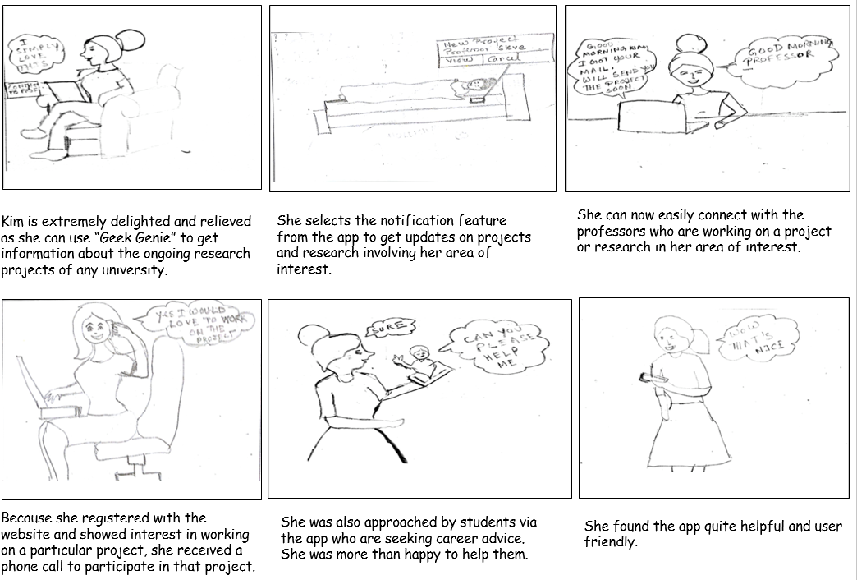

# Section 14: Prototype Sitemap

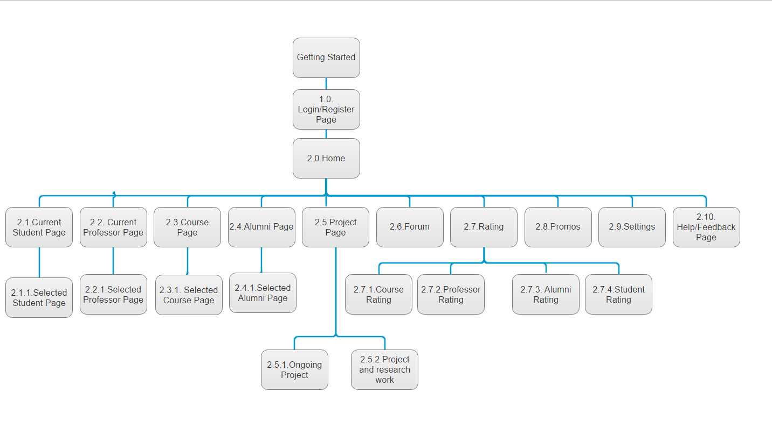

# Section 15: Prototype Screenshots and Descriptions

## Screen Name: Home Screen

|  |  |
| --- | --- |
|  | Home Screen:  When user downloads GeekGenie app, this screen will be displayed.  Home screen is designed with images and text. This helps user to understand the purpose of downloading the application and its motto.  Motto of the app is to connect students, professors, courses, alumni, projects based on relative search and ratings. |

## Screen Name: Hamburger Menu

|  |  |
| --- | --- |
|  | Hamburger Menu:  It is designed with important options, which facilitates the user to navigate the important screens with **one click**. |

## Screen Name: Fellow Students Search Page

|  |  |
| --- | --- |
|  | To search Fellow Students:  A click on “Current Students” option in Hamburger Menu takes user to this screen.  User has functionality to perform advance searches and filter the results based on degree, major, class or University. |

## Screen Name: Fellow Student Search result page

|  |  |
| --- | --- |
|  | A click on “search” button displays two sections of search results as shown in the screenshot. |

## Screen Name: Fellow Student details page

|  |  |
| --- | --- |
|  | A click on “view profile” button in the above screenshot navigates user to this page. Here, the student profile is displayed with ratings. |

## Screen Name: Fellow Student rating questionnaire page

|  |  |
| --- | --- |
|  | The “rate” button in above screenshot navigates to this page. User can provide rating to the respective student. |

## Screen Name: Professor Search page

|  |  |
| --- | --- |
|  | To search Professors:  A click on “Professors” option in Hamburger Menu takes user to this screen.  User has functionality to perform advance searches and filter the results based on Rating, Professor name, course or University. |

## Screen Name: Professor Search result page

|  |  |
| --- | --- |
|  | A click on “search” button displays two sections of search results as shown in the screenshot. |

## Screen Name: Professor details page

|  |  |
| --- | --- |
|  | A click on “view profile” button in the above screenshot navigates user to this page. Here, the professor profile is displayed with ratings. |

## Screen Name: Professor rating questionnaire page

|  |  |
| --- | --- |
|  | The “rate” button in above screenshot navigates to this page. User can provide rating to the respective professor. |

## Screen Name: Course Search page

|  |  |
| --- | --- |
|  | To search Courses  A click on “Courses” option in Hamburger Menu takes user to this screen.  User has functionality to perform advance searches and filter the results based on Ratings, Professor Name, course or University.. |

## Screen Name: Course Search results page

|  |  |
| --- | --- |
|  | A click on “search” button displays two sections of search results as shown in the screenshot. |

## Screen Name: Course details page

|  |  |
| --- | --- |
|  | A click on “view details” button in the above screenshot navigates user to this page. Here, the detailed summary of the course is displayed. |

## Screen Name: Course rating questionnaire page

|  |  |
| --- | --- |
|  | The “rate this course” button in above screenshot navigates to this page. User can provide rating to the respective course. |

## Screen Name: Alumni Search Page

|  |  |
| --- | --- |
|  | To connect with Alumni  A click on “Alumni” option in Hamburger Menu takes user to this screen.  User has functionality to perform advance searches and filter the results based on Alumni Name, degree, major, Year or Job Role. |

## Screen Name: Alumni Search results page

|  |  |
| --- | --- |
|  | A click on “search” button displays two sections of search results as shown in the screenshot. |

## Screen Name: Alumni details page

|  |  |
| --- | --- |
|  | A click on “view profile” button in the above screenshot navigates user to this page. Here, the Alumni profile is displayed with ratings. |

## Screen Name: Alumni rating questionnaire page

|  |  |
| --- | --- |
|  | The “rate” button in above screenshot navigates to this page. User can provide rating to the respective Alumni member. |

## Screen Name: Ongoing Projects & Research Search page

|  |  |
| --- | --- |
|  | To search Ongoing projects and research  A click on “Ongoing Project/research” option in Hamburger Menu takes user to this screen.  User has functionality to perform advance searches and filter the results based on Project Name, Course Name, Professor and Teammates. |

## Screen Name: Ongoing Project/Research Search results page

|  |  |
| --- | --- |
|  | A click on “search” button displays a section of search results as shown in the screenshot. |

## Screen Name: Ongoing Project/Research details page

|  |  |
| --- | --- |
|  | A click on “view details” button in the above screenshot navigates user to this page. Here, the details of project are displayed with ratings. |

## Screen Name: Forums Search page

|  |  |
| --- | --- |
|  | A click on “Forums” option in Hamburger Menu takes user to this screen.  User has option to search a particular forum, create a new forum or a post a question. |

## Screen Name: Forums Search results page

|  |  |
| --- | --- |
|  | A click on “search” button displays a section to perform advance searches and filter the results based on Name, Category and Topic Thread. |

## Screen Name: Settings page

|  |  |
| --- | --- |
|  | A click on “Settings” option in Hamburger Menu takes user to this screen. |

## Screen Name: Promos page

|  |  |
| --- | --- |
|  | A click on “Promos” option in Hamburger Menu takes user to this screen. |